Difference Between Straw and Hay

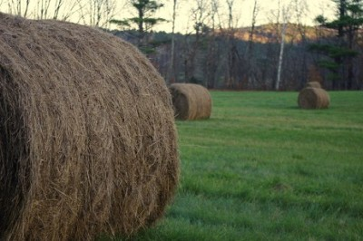

Until recently, I thought hay and straw were the same thing.
Hayrides, barn floors, over-stuffed scarecrows and cows munching on grass – that’s what I knew growing up in Maine. I went to the Scarborough Fair and checked out the 4-H animals but never payed attention to the stuff.

Now I know the basics and it seems so obvious that “Hay IS for Horses”. These fun facts and images should permanently clear things up if you’re still on the fence about which is which and what is for what. I’m mulching with straw in my garden and figured I’d show you what I learned.

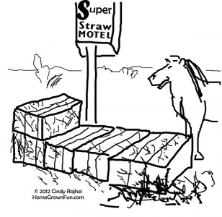

STRAW
Straw is a by-product of the grain harvest, e.g., wheat, oats and barley.

COLOR: Straw is yellow or golden in color – think straw hats and baskets.

HOW IS IT MADE? The hollow stalks leftover after threshing are dried, then cut and formed into bales. Bales of straw have very little moisture content.

NUTRITIONAL VALUE: There isn’t much nutritional value in dry straw, therefore it’s not usually fed to livestock.

USES: Because it’s light and fluffy, it makes a nice bedding for animals. Straw can mulch your plants and keep the soil moist, keeping the top layer from drying out. It can also suppress weeds and it will compost naturally into your garden over time. Did you know straw is used as an ingredient in biofuels, packaging materials and paper manufacturing?

Get a load of this: Straw bales can support and insulate a house. Green home manufacturers are now constructing straw bale homes!

HAY
Hay is legumes such as alfalfa and clover or grasses such as timothy, oat, fescue and bermuda. Most of the time, seeds are still intact in a hay bale.

COLOR: Hay is green, especially when seen next to the more golden hue of straw.

HOW IS IT MADE? Plants are harvested when alive and usually cut before the seed matures, then dried. Hay bales sometimes have too much moisture content on the inside and can mold (bad for animals) or even burst into flames because heat increases on the inside due to the decomposition process.

NUTRITIONAL VALUE: There are many types of hay used to feed livestock. Some contain more protein and carbohydrates to fuel hard working horses. Specific types of hay are fed to animals depending on their nutritional needs.

USES
Horses, cows, sheep, goats and other animals eat hay especially when fresh pasture is not available due to seasonal or access limitations.

